# IOT BASED ORGANIC FORMING BY USING AQUAPONICS METHOD

**Project Requirements**

**Aim:**

One of agricultural cultivation technology development that is worth disseminating is the aquaponic agricultural technique. Aquaponics is a method of organic farming that can be used indoors as well as outdoors, in areas of any size. This allows people to grow their own organic crops that do not use any external chemical fertilizers with some light, temperature, and humidity manipulation of the plant; it will be well suited to be applied to indoor systems. Agricultural technology design with aquaponics is also using the concept of Internet of Things because the information from the sensor and control actuator values can be accessed through applications installed on the smartphone from anywhere with the Internet connection. Agricultural cultivation technology with indoor aquaponic agricultural technology provides an alternative for anyone who has no land for farming but can still conduct business activities that can be used as an adequate source of food or income. The agricultural techniques applied to aquaponics are very different from conventional farming techniques. With technology using the concept of Internet of Things has more advantages compared with conventional farming.

Smart Aquaponic with Monitoring and Control

System Based On IoT

Abstract— One of agricultural cultivation technology

Development that is worth disseminating is the aquaponic

Agricultural technique that will be our idea in this writing. With

Some light, temperature, and humidity manipulation of the plant,

It will be well suited to be applied to indoor systems. Agricultural

Technology design with aquaponics is also using the concept of

Internet of Things because the information from the sensor and

Control actuator values can be accessed through applications

Installed on the smartphone from anywhere with the Internet

Connection. Agricultural cultivation technology with indoor

Aquaporin agricultural technology provides an alternative for

anyone who has no land for farming but can still conduct

Business activities that can be used as an adequate source of food

Or income. The agricultural techniques applied to aquaponics are

Very different from conventional farming techniques. With

Technology using the concept of Internet of Things has more

Advantages compared with conventional farming.

**Hardware & Software Requirements:**

1. NODE MCU
2. ULTRASONIC SENSOR
3. Embedded c
4. DHT 11(TEMPERATURE AND HUMIDITY SENSOR)
5. SOIL MOISTURE SENSOR
6. PH LEVEL INDICATOR
7. WATER SENSOR
8. WATER LEVEL INDICATOR
9. FISH FEEDER
10. ADAFRUIT IO
11. IFTTT
12. BUZZER
13. LED INDICATOR
14. LED GROW LIGHT
15. WATER PUMP
16. TEMPERATURE SENSOR
17. POWER SUPPLY
18. TRANSFORMER
19. 5V ADAPTER
20. SIGNAL PIN FEMALE TO FEMALE CONNECTORS-40
    1. **Project Flow:**

PH LEVEL LED INDICATOR

Node mcu

UTRASONIC SENSOR

PH LEVEL DETECTOR

BUZZER



TEMPERATURE SENSOR

Cloud

WATER SENSOR

FISH FEDER

DHT11 SENSOR

PUMP

SOIL MOISTURE SENSOR

Power supply

**PROPOSED SYSTEM**

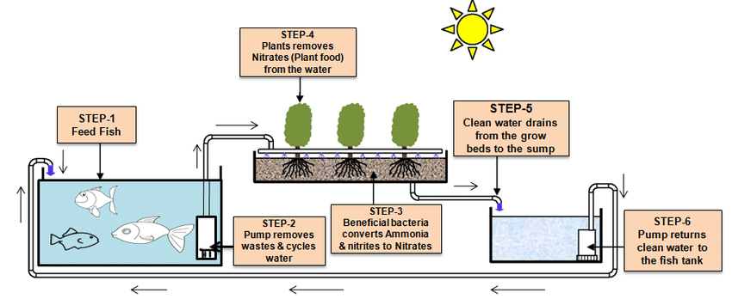

**TYPES OF SOLUTIONS AQUAPONICS MARKET:**

**BY CULTIVATION -** Fishes, Herbs, Fruits and Vegetables Plants.

**BY APPLICATIONS -** Commercial, Community, Home production, Research centers, Agriculture & Farming

The aquaponics market report also analyzes the major geographic regions for the market as well as the major countries for the market in these regions.

**A) AQUAPONICS MARKET TO GROW ON ACCOUNT OF THE SUSTAINABILITY ITOFFERS**  
Aquaponics is a combination of hydroponics and aquaculture which is leveraged for food production. The system creates a symbiotic ecosystem by using the waste produced by fishes as nutrients for growing plants. Additionally, the water used for rearing fish and growing plants is also re-circulated within the system. Aquaponics promote sustainability and provide organic vegetables while reducing the production of waste substantially. Further, the system provides for an efficient way of growing vegetables in an eco-friendly manner, a capability that is expected to prove vital to aquaponics market growth. As demand for organic vegetables continues to stay on the rise, farmers are gradually adopting aquaponics for cultivation of fresh organic vegetables which, in turn, is estimated drive the growth of the aquaponics market. In addition to this, locally grown vegetables are fresh, better tasting, have a longer shelf life and incur nominal transportation costs. Owing to these factors, an increasing number of retailers are sourcing locally grown vegetables. Moreover, longer transportation times and storage of vegetables result in damage to their quality which eventually hurts the sales. Further, farmers with no access to extensive distribution and sales network could benefit from the growing demand for local produce, a factor that is expected to boost the [aquaponics market](https://www.persistencemarketresearch.com/mediarelease/aquaponics-market.asp) growth.   
  
**B) AQUAPONICS MARKET GROWTH TO BE UPHELD BY TECHNOLOGICAL ADVANCEMENTS**  
Continuous integration of technology in the existing aquaponics system is expected to aid farmers in streamlining the process which, in turn, is likely to boost production and provide for faster cultivation times. For instance, recent research studying the development of an IoT-based aquaponics monitoring system was recently released. As a part of the research, an aquaponics monitoring system was developed which could effectively monitor the pH values, humidity, temperature, and the water level of the whole system. The monitoring system used specific sensors to measure each of the values and then displayed it on an LCD and a web application designed for the monitoring system. Using these values, farmers could effectively manage the aquaponics ecosystem which can potentially boost production and reduce costs. Another research conducted along similar lines claimed developing an innovative aquaponics system which could provide for superior quality vegetables with great taste and in large numbers owing to the system’s ability to bolster production rate, yield, and shorten the time required for cultivation. Innovation is expected to contribute significantly towards aquaponics market growth.  
  
**C) ECONOMIC SUSTENANCE OFFERED BY AQUAPONICS TO AUGMENT TO ITS RISINGPOPULARITY**  
Aquaponics is easy to set up and do not require expert supervision. In addition to this, the system offers a great degree of economic sustenance after setup. Unlike, hydroponics farmers are not required to invest in fertilizers and other soil-fertility enhancing chemicals with the waste from fish supplementing the soil with the required nutrients. Consequentially, soil used for cultivating crops does not require to be changed frequently which saves farmers both time and money. Additionally, aquaponics market is also expected to bolster owing to the system’s ability of utilizing substantially less area for growing fish and plants as compared to hydroponics and aquaculture. Farmers are continuously growing aware of the plethora of benefits offered by aquaponics which is gradually causing a shift towards adoption of the system over orthodox hydroponics and aquaculture practices and is expected to fuel the aquaponics market growth.   
  
**D) ENORMOUS SET UP COSTS TO HAMPER AQUAPONICS MARKET PROLIFERATION**  
although economical in the long-run, setting up aquaponics system requires a large amount of investments. On average materials and other equipment for setting up the growing area for aquaponics can range between $5 to $20 which is expensive making the commercial setup of these facilities expensive. While selling the produce cultivated by leveraging the system can bolster profits the requirement of massive investments at the beginning is making farmers reluctant to invest in the aquaponics market. The requirement for high initial investments in the system is estimated to continue to pose a challenge to the aquaponics market proliferation.

INTERNNET CONNECTION